**Conditional and Independence-Joint Distribution Problems**

1. Let X and Y be two jointly continuous random variables with joint PDF

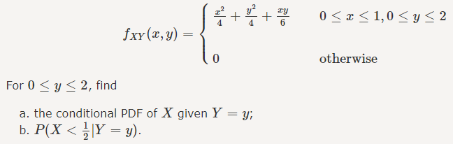

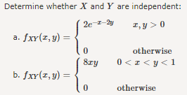

3.

